UNO Q AI Starter Kit Product Overview
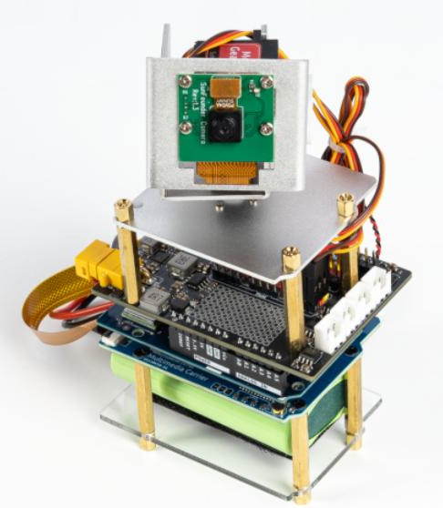

Product Overview
The SunFounder AI Starter Kit with Arduino Uno Q is an all-in-one learning platform for AI, programming, and interactive electronics. It combines modular hardware, a ready-to-use software environment App Lab, and step-by-step lessons to help users build hands-on projects with computer vision, voice interaction, and multi-LLM AI technologies.
Main Content
Features the Robot Shield, Multimedia carrier, camera, pan-tilt module, sensors, and electronic components, enabling hands-on AI projects with vision recognition, voice interaction, and hardware control.
Target Users
Aged 10+ students, educators, makers, and engineers.
Application
Object recognition, face recognition, gesture recognition, voice interaction and control, pan-tilt tracking systems, multi-LLM interactive applications, and smart home systems.

Core Hardware

Robot Shield x 1
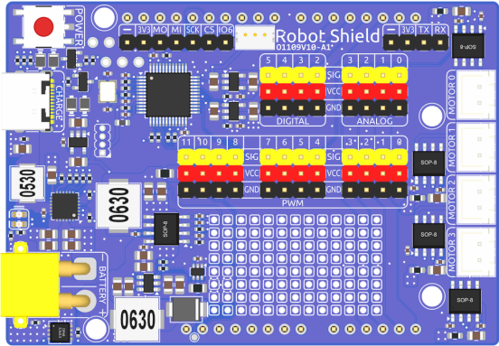

Key Features:
- Battery Management: 2S lithium battery charging (7.4V/1.5A, 15W) via USB-C, with overcharge/reverse polarity protection
- Motor Driver: 4 independent H-bridge motor channels (7.4V/1A each)
- Servo Driver: 12-channel PWM output (5V/4A total) for servos and LEDs
- Multi-rail Power: Separate power rails for Ard ui no (12V/1.5A), servos (5V/5A), and sensors (3.3V/5V selectable via IOREF)
- Onboard MCU: Real-time Arduino current monitoring, auto-shutdown when idle (<50mA), I2C communication (default address 0x20)
- Power Button: Multi-function: power on/off, soft shutdown, servo zeroing mode, user key input
- Battery Indicator: 2 LEDs with charging animation
- Expansion Headers: Digital/analog I/O headers, SPI interface, WS2812 RGB LEDsupport

Multimedia Carrier × 1
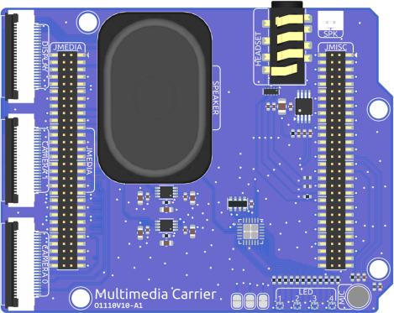
Key Features:
- Camera Interfaces: 2 CSI camera connectors for dual-camera setups
- Display Interface : 1 DSI display connector for touchscreen or panel display
- Audio Input: Onboard microphone for voice/sound capture
- Audio Output: Mono speaker (4Ω/3W) for built-in audio playback
- Headphone Jack: 3.5mm headphone connector with dual-channel stereo output
- RGB LEDs: 4 programmable RGB LEDs for status indication or user feedback

10-Axis IMU × 1
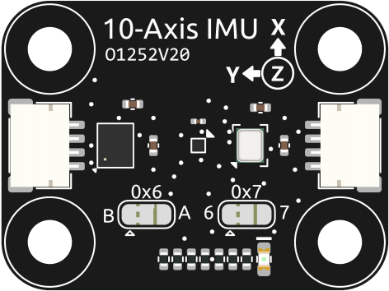

Integrated motion sensing module:
- 3-axis Accelerometer: Detect linear acceleration and tilt
- 3-axis Gyroscope: Measure rotational velocity
- 3-axis Magnetometer: Detect magnetic field (compass)
- Barometer _ Measure atmospheric pressure
- Interface: QWIIC connector, Modulino compatible

Camera Module with FFC Cable × 1
CSI camera for visual input and image processing projects.

Metal Gear Pro Servo × 2
High-quality servos for pan-tilt system and other motion control applications.

Pan-Tilt Mount × 1
Dual-servo pan-tilt system for camera control:
- 2-axis Movement: Pan (left/right) and tilt (up/down) control
- Applications: Camera tracking, head movement simulation for robotics

Sensor Modules
Name | Qty | Description
Ultrasonic Module | 1 | Ultrasonic distance sensor
DHT11 Module | 1 | Temperature and humidity  sensor
Photoresistor | 1 | Light-dependent resistor for detecting light intensity
Thermistor | 1 | Temperature-sensitive resistor

Input/Output Modules
Name | Qty | Description
Joystick Module | 1 | Dual-axis joystick module
Active Buzzer | 1 | Active buzzer
Passive Buzzer | 1 | Passive buzzer (can play tones)
Potentiometer | 1 | Potentiometer for analog input
Tilt Switch | 1 | Tilt switch sensor
RGB LED | 1 | Programmable RGB LED
LED  (Red/Green/Blue/Yellow/White) | 5 each | Basic LED components
3V Motor | 1 | Small DC motor
Fan | 1 | Fan module

Electronic Components
Name | Qty | Description
NPN S8050 Transistor | 5 | NPN transistor
PNP S8550 Transistor | 5 | PNP transistor
104pF Capacitor | 10 | Capacitor
Resistor (10Ω~1MΩ) | Various | Resistor kit
Resistor Card | 1 | Resistor reference card
Buttons (various sizes) | 14 | Button components

Connection & Accessories
Name | Qty | Description
Breadboard | 1 | Breadboard for prototyping
Jumper Wires | 1 set | Jumper wire kit
Dupont Wires (M-F) | 20 | Male-to-Female Dupont wires
Dupont Wires (F-F) | 10 | Female-to-Female Dupont wires
SH1.0-4P Wire | 2 | SH1.0 connector wires
Type-C USB Cable | 1 | Type-C data cable

Mechanical Parts
Name | Qty | Description
Acrylic Plate | 1 | Acrylic board
Standoffs (various sizes) | 26 | Standoffs/spacers
Screws (various sizes) | 33 | Screw kit
Nuts & Washers | 11 | Nuts and washers
Cable Tie | 4 | Cable ties
Loop Tape | 2 | Velcro tape
Screwdriver | 1 | Screwdriver
Phillips Socket | 1 | Phillips bit

Packing List

No. | Picture | Name | Qty.
1. | 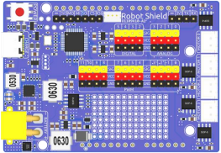 | Robot Shield | 1
2. | 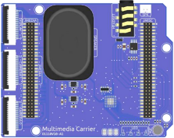 | Multimedia Carrier | 1
3. | 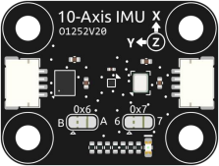 | 10-Axis IMU | 1
4. | 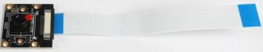 | Camera Module with FFC Cable | 1

5. | 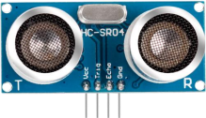 | Ultrasonic Module | 1
6. | 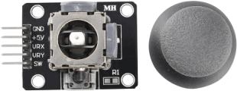 | Joystick Module | 1
7. | 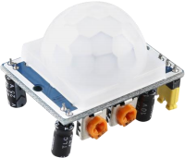 | PIR Motion Sensor Module | 1
8. | 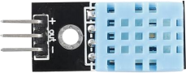 | DHT11 Module | 1
9. | 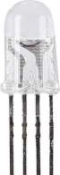 | RGB LED | 1

10. | 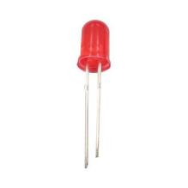 | Red LED | 5
11. | 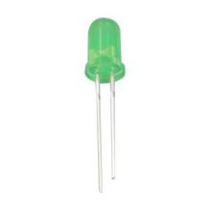 | Green LED | 5
12. | 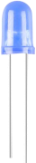 | Blue LED | 5
13. | 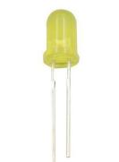 | Yellow LED | 5

14. | 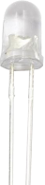 | White ;ED | 5
15. | 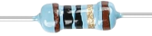 | 10Ω Resistor | 10
16. |  | 100Ω Resistor | 10
17. |  | 220Ω Resistor | 30
18. |  | 330Ω Resistor | 10
19. | 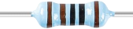 | 1KΩ Resistor | 10
20. | 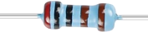 | 2KΩ Resistor | 10
21. |  | 5.1KΩ Resistor | 10
22. |  | 10KΩ Resistor | 10
23. | 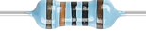 | 100KΩ Resistor | 10

24. |  | 1MΩ Resistor | 10
25. | 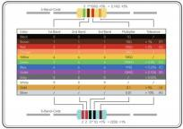 | Resistor Card | 1
26. | 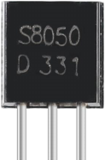 | NPN S8050 Transistor | 5
27. | 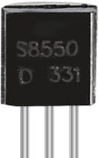 | PNP S8550 Transistor | 5
28. | 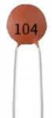 | 104pF Capacitor | 10
29. | 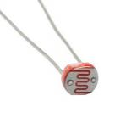 | Photoresistor | 1

30. | 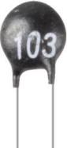 | Thermistor | 1
31. | 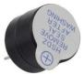 | Active Buzzer | 1
32. | 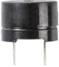 | Passive Buzzer | 1
33. | 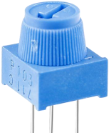 | Potentiometer | 1
34. | 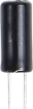 | Tilt Switch | 1
35. | 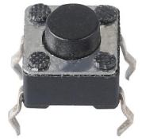 | 6*6*5MM Small Button | 10

36. | 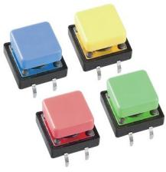 | 12*12*7.3 MM Button | 4
37. | 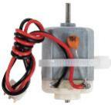 | 3V XH2.54 2Pin Motor | 1
38. | 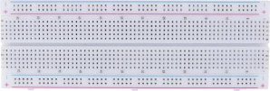 | Breadboard | 1
39. | 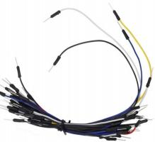 | Jumper Wires | 1
40. | 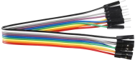 | Male to Female Dupont Wires | 20
41. | 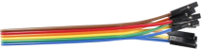 | Female to Female Dupont Wires | 10

42. | 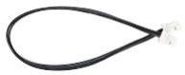 | SH1.0-4P Wire | 2
43. | 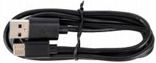 | Type-C USB Cable | 1
44. | 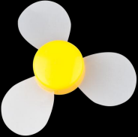 | Fan | 1
45. | 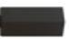 | M2.5x8 Standoff | 10
46. |  | M2.5x20+6mm Standoff | 10
47. |  | M2.5x25+6mm Standoff | 6
48. | 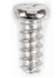 | PB2.5x6 Screw | 6
49. | 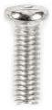 | M2.5 x 8 Screw | 11

50. | 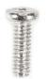 | M2*6 Screw | 6
51. | 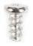 | M1.5x3 Screw | 10
52. | 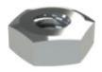 | M2 Nut | 6
53. | 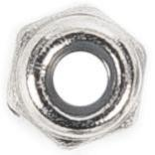 | M2.5Self-locking Nut | 3
54. | 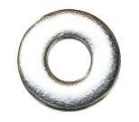 | 2mm Washer | 2
55. | 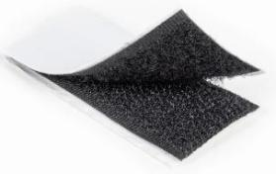 | Loop Tape | 2
56. | 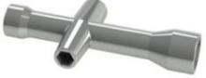 | Phillips Socket | 1

57. | 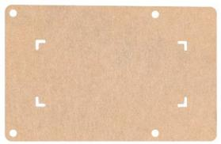 | Acrylic Plate | 1
58. | 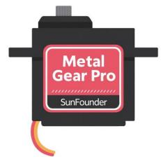 | Metal Gear Pro Servo | 2
59. | 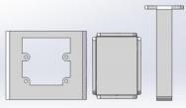 | Pan-Tilt Mount | 1  S0107v13
60. | 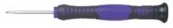 | 2.0*40mm Screwdriver | 1
61. | 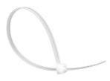 | Cable Tie | 4

Course Outline
This course is designed based on the Arduino UNO Q and Arduino App Lab platform. Through hardware experiments, IoT applications, and AI technology practices, learners are gradually guided to master electronic control, device interaction, cloud connectivity, and intelligent device development.
The course is divided into four modules, progressing step by step from basic hardware control → IoT system development → AI interaction applications → Edge AI development.

Module A: Basic Interaction (13 lessons)
Exploring Arduino App Lab and basic hardware control
Through experiments with LEDs, sensors, and actuators, students learn the fundamental concepts of Arduino development, including digital input/output, analog signal processing, PWM control, and hardware interaction.

Course Content:
1. Introduction to UNO Q and App Lab
Learn about the UNO Q hardware structure, expansion board interfaces, and the Arduino App Lab development environment.
2. Blinking LED Experiment
Control an LED to blink periodically and understand program structure and digital output.
3. Button Control LED
Use a button to control turning the LED on and off.
4. RGB LED Color Mixing
Use a potentiometer to adjust the brightness and color of the RGB LED.
5. Tilt Alarm
Use a tilt switch and buzzer to create an anti-tilt alert device.
6. Automatic Night Light
Automatically control the LED based on ambient light intensity.
7. Temperature and Humidity Detection
Use the DHT11 sensor to read temperature and humidity data.
8. Reverse Parking Radar
Use an ultrasonic module to measure distance and trigger a buzzer alert.
9. Temperature-Controlled Fan
Adjust motor speed automatically based on temperature changes.
10. Joystick Control
Use a joystick to control LED brightness or RGB LED colors.
11. Pan-Tilt Control
Use a joystick to control the direction of a camera pan-tilt module.
12. Orientation Detection
Use a 10-axis IMU module to detect device orientation changes.
13. Arduino IDE Comparison Lesson
Introduce the Arduino IDE and compare App Lab with traditional Arduino development methods.

Module B: UI / Arduino Cloud / IoT Applications (7 lessons)
Building IoT and remote control applications
Learn to use Arduino App Lab UI and Arduino Cloud to create IoT applications, enabling remote device control, data uploading, and visualization.

Course Content:

1. UI Control LED
Use a web button to control an external LED.
2. UI Control RGB LED
Adjust RGB LED colors through a web interface.
3. Arduino Cloud Control Buzzer
Control a buzzer to play notes through Arduino Cloud.
4. Environmental Monitoring System
Upload temperature, humidity, and light data to Arduino Cloud.
5. Web Game Interaction
Use a button to control a web character jumping to avoid obstacles.
6. Home Climate Monitoring System
Display environmental data on a web dashboard in real time.
7. Telegram Bot Device Control
Use a Telegram bot to remotely read sensor data and control LEDs.

Module C: Large Language Model Applications (4 lessons)
AI-driven intelligent interaction applications. Combine large language models (LLMs) with hardware devices to explore AI applications in smart devices and IoT systems.

Course Content:

1. AI Chatbot
Connect to Gemini or ChatGPT to create a text-based chatbot.
2. AI-Controlled Lighting
Use natural language commands to control RGB LEDs, such as turning lights on/off or changing colors.
3. AI Digital Pet
Display facial expressions on an LED matrix and change the pet’s behavior through AI interaction.
4. AI Pan-Tilt Interaction
AI evaluates user responses and controls the pan-tilt module to nod or shake.

Module D: Edge Impulse Applications (10 lessons)
Learn to use Edge Impulse and Edge AI technologies. Through cameras and microphones, students will implement vision recognition, speech recognition, and intelligent control, while mastering AI model training and deployment.

Course Content:

- AI Vision Recognition Introduction
- Recognize objects such as cups, people, and phones
- Display results in the Web UI
- AI Voice Wake-up
- Detect keywords such as “Hello Arduino”
- Trigger buzzer feedback

- AI Object Tracking Pan-Tilt
- Detect faces with the camera
- Pan-tilt module automatically follows the target
- AI Gesture Control
- Use gestures to control LEDs or buzzers
- Gestures act as commands
- AI Vision Alarm System
- Detect a person → trigger buzzer alarm

- Voice Control System
Voice commands such as:
- Turn on lights
- Rotate pan-tilt module
- Activate buzzer
- Advanced AI Voice Assistant
- STT + TTS
- Play voice feedback through speakers
Example:
“Turn left” → Pan-tilt turns left + voice response.
- Voice + Vision Integration
Voice question:
“What do you see?”
AI responds with detected objects.

- Smart Environmental Monitoring
- Use DHT11 to read temperature and humidity
- Voice broadcasting of sensor data
- Custom Voice Recognition
Train custom keywords such as:
- “Robot”
- “Start”
- Custom Object Recognition
Train the system to recognize personal desk objects.
- AI Smart Security Camera
- Human detection
- Automatic tracking
- Alarm + voice alert
- AI Smart Home Control System
- Voice-controlled devices
- Environmental monitoring
- Web-based control interface
- AI Behavior Detection System (Advanced)
- IMU + Camera
- Detect user behaviors such as standing or moving

